Week 7

Operating System

Phase 7's goal is to verify the performance configurations, security controls, and monitoring systems put in place during Phases 3–6. Verifying system readiness, examining gathered data, and recording final system behaviour under safe operating conditions are the main objectives of this phase.

- Security Control Validation:

All security mechanisms are verified using manual and automated checks.

Controls that are validated:

- Disabled root login
- SSH key-based authentication
- Firewall (UFW) active with restricted inbound access
- Fail2Ban intrusion prevention enabled
- Automatic security updates configured
- Principle of least privilege enforced via sudo users

The security baseline script was executed via SSH remotely. The evidence of that is given below.
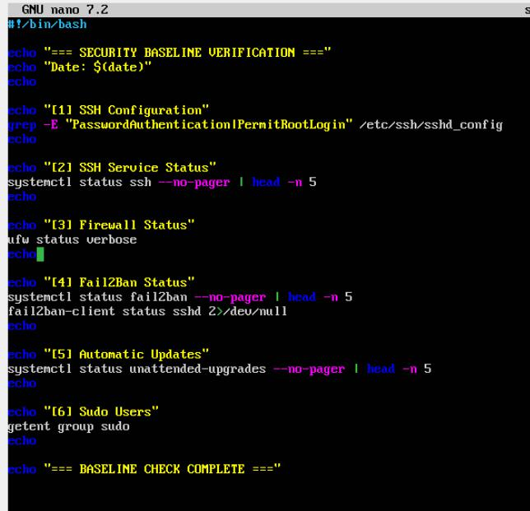

Fabian Gill A00017906

Fabian Gill | A00017906
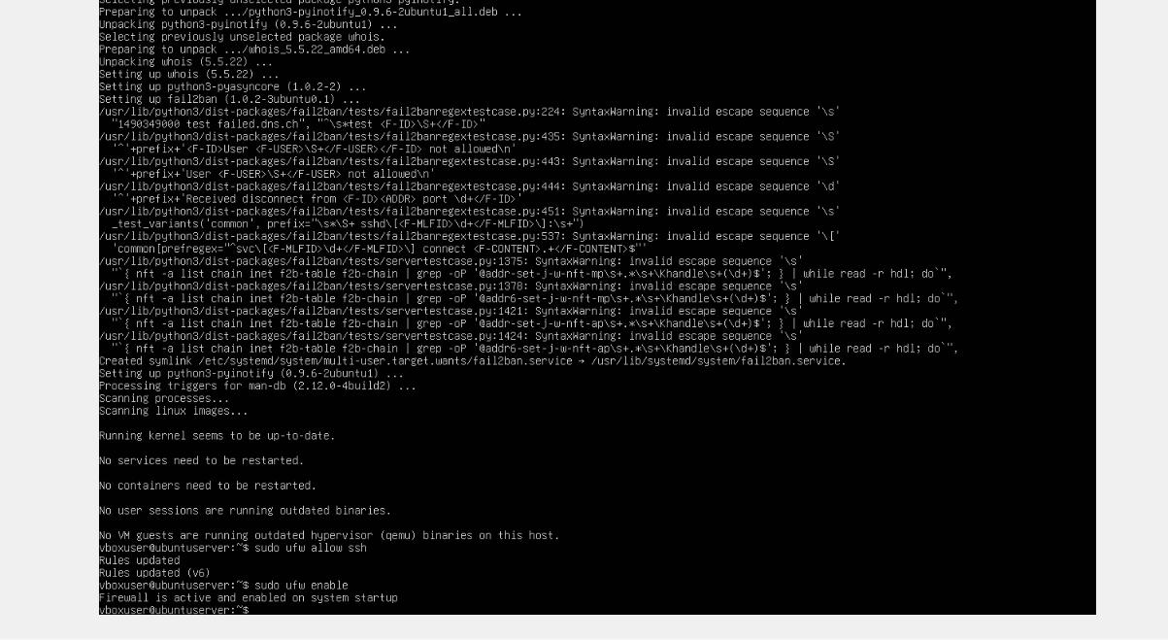
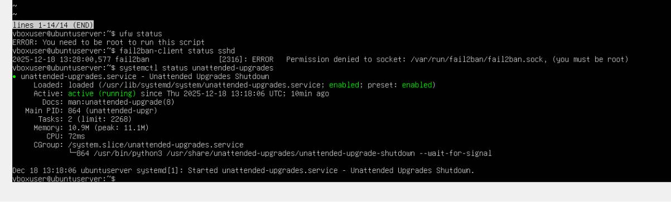
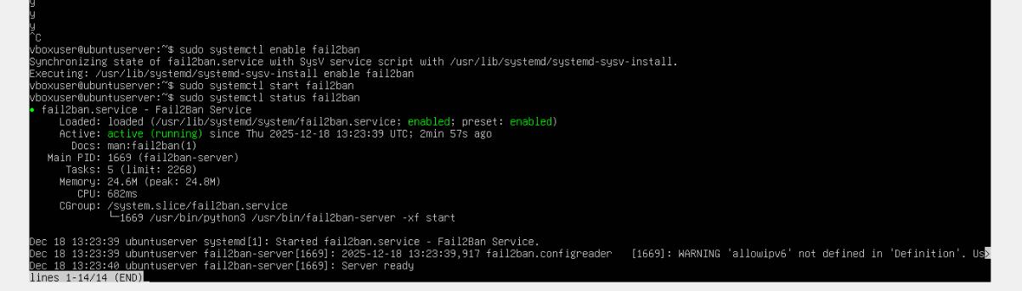
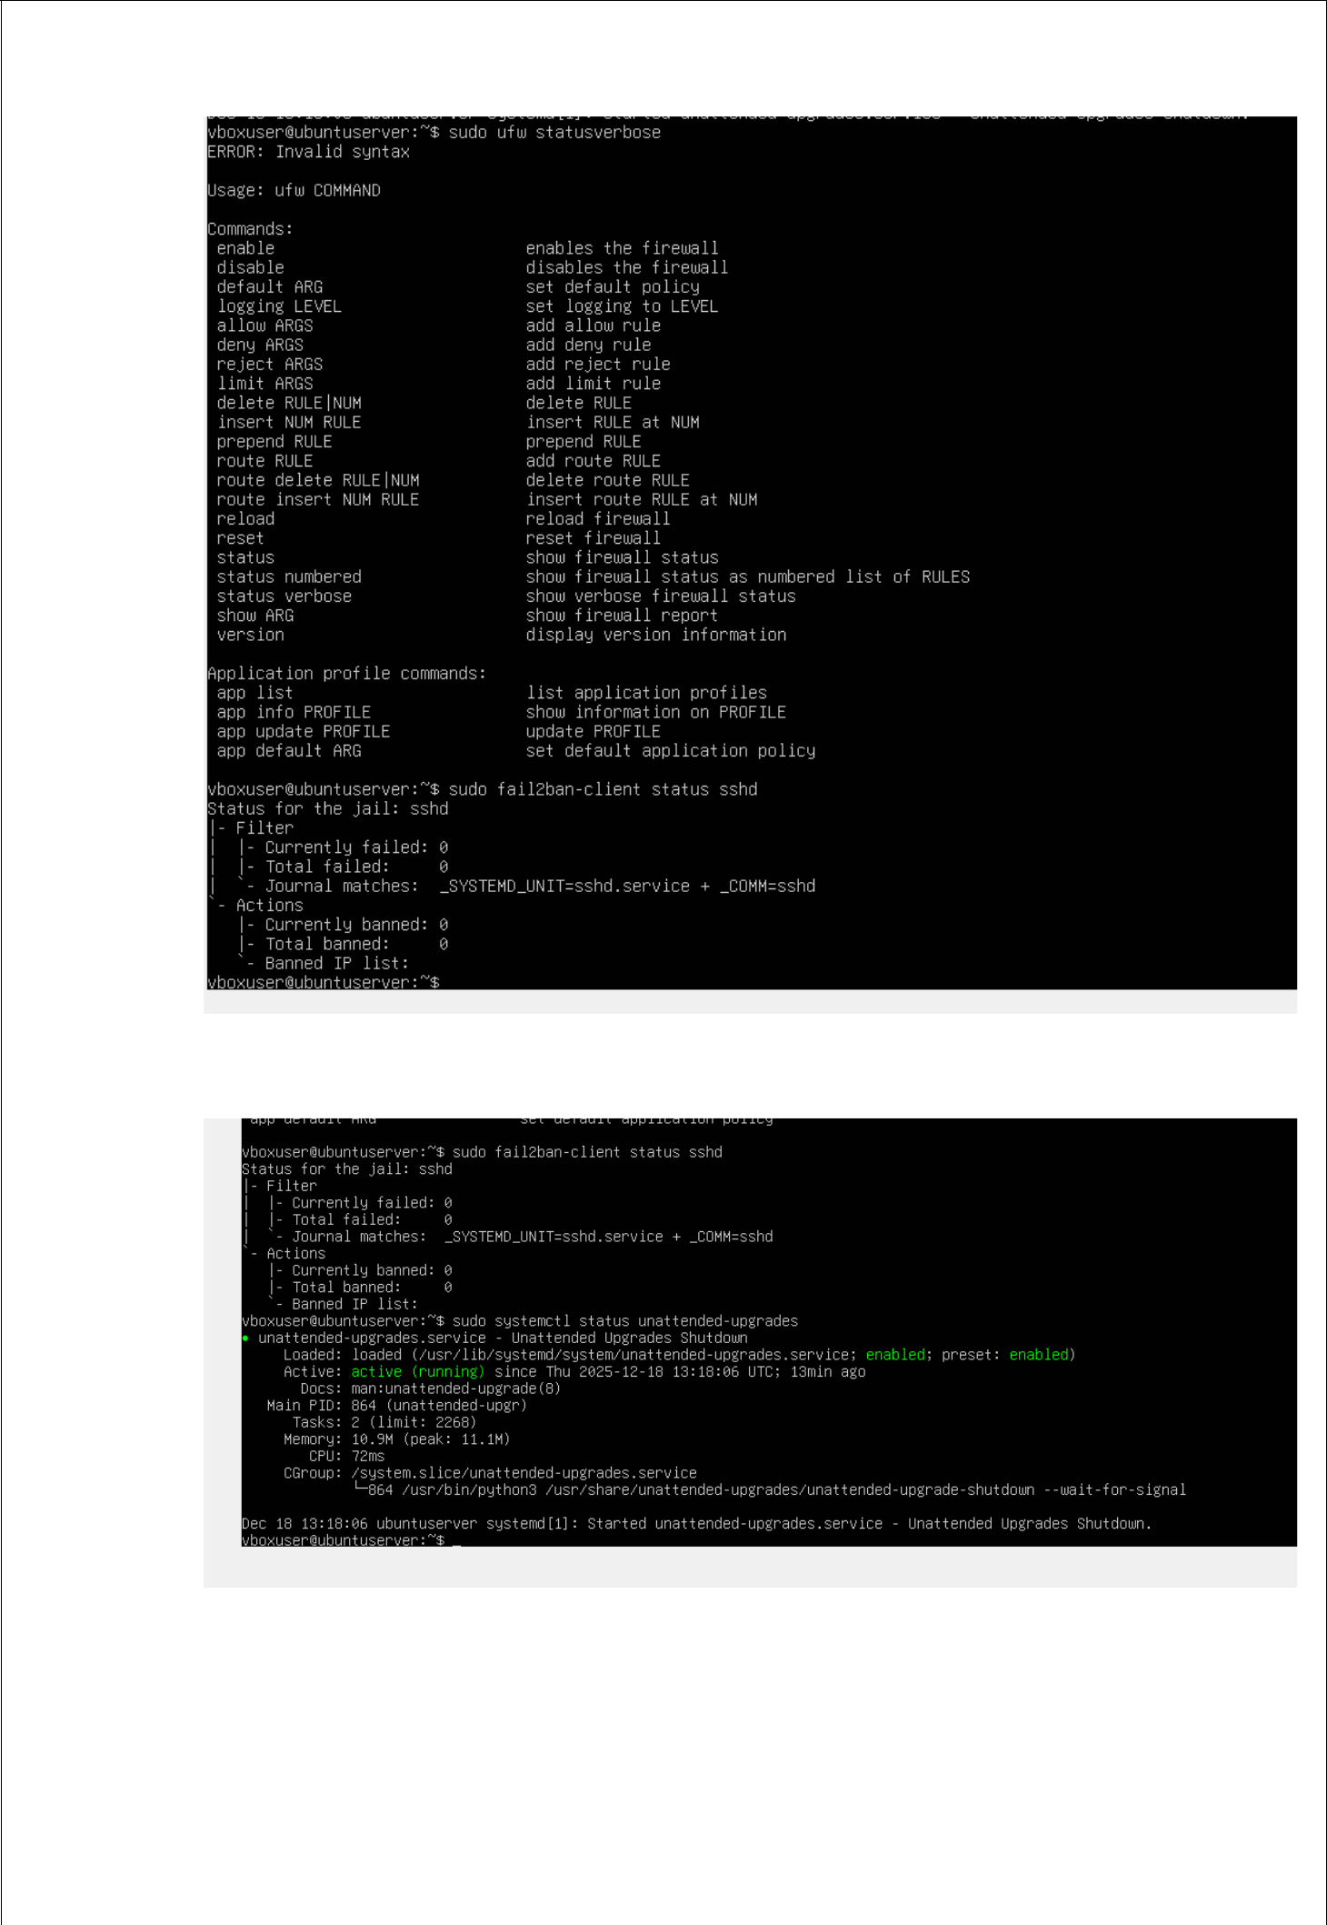

- Performance and Monitoring Validation:

- workstation-based script was used to gather real-time server metrics in order to validate remote monitoring.

Fabian Gill | A00017906

The evidence of that is given below where the execution of monitoring in the form of script is given below.

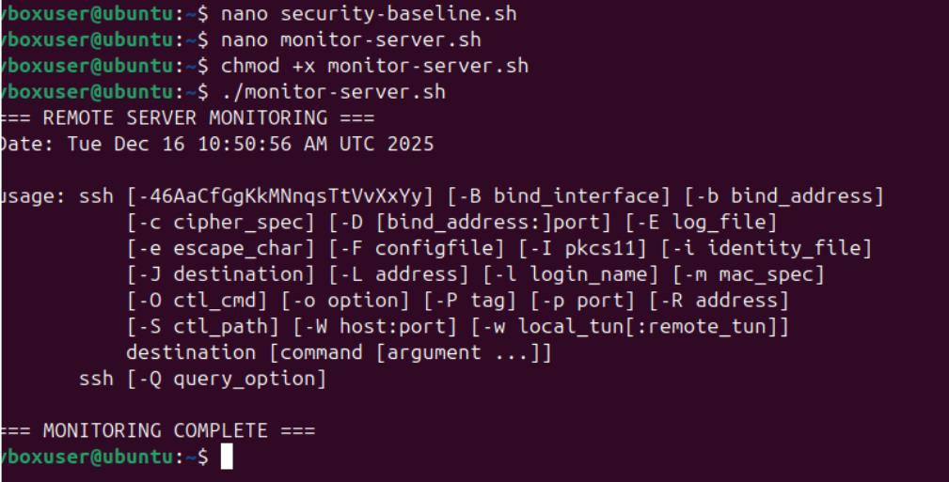

- Performance Analysis Summary:

 | Resource | Observed Behaviour | Interpretation
 | CPU | Low utilization during idle | System adequately provisioned
 | Memory | Stable usage | No memory pressure detected
 | Disk | Sufficient free space | Storage capacity acceptable
 | Network | Minimal idle traffic | No abnormal network behaviour

- System Stability & Reliability Assessment:

  - There were no service crashes.
  - After rebooting, security services continued to function.
  - Firewall rules held true between sessions.

  - With key-based authentication, SSH access was still operational.

This attests to the system's stability and readiness for production within the project's parameters.

- Risk Assessment & Mitigation Review:

 | Risk | Mitigation Implemented
 | Unauthorized SSH access | Key-based auth + Fail2Ban
 | Brute-force attacks | Fail2Ban SSH jail

Fabian Gill A00017906

 | Unpatched vulnerabilities | Automatic security updates
 | Excessive privileges | Non-root sudo administration
 | Network exposure | UFW firewall

- LYNIS SECURITY SCAN:

This is my lynis security scan below:

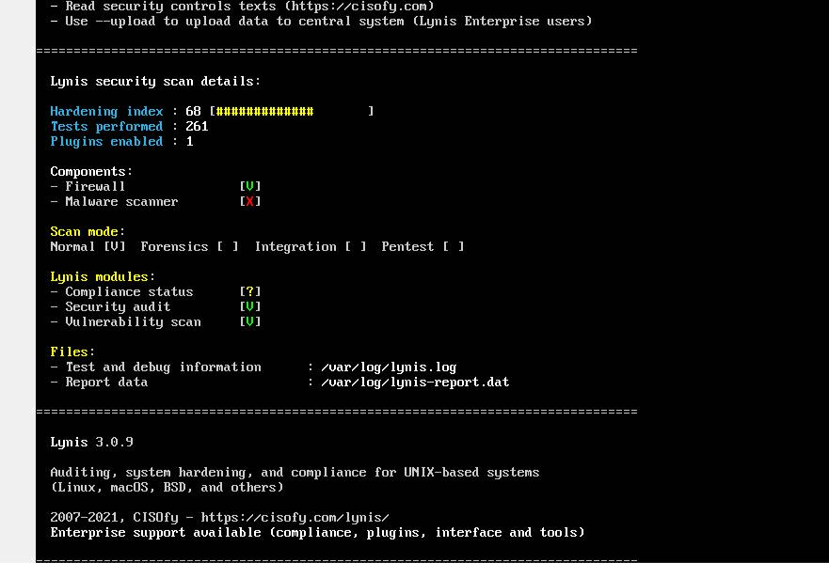

Results of the Security Audit (Lynis):

Lynis, a system hardening and security auditing tool for Linux systems, was used to perform a security audit.

The following command was used to carry out the audit:

“sudo lynis audit system”

Interpretation of the Audit Summary

The Lynis scan yielded the following findings:

Index of Hardening: 68
Tests Conducted: 261
Enabled Plugins: 1

An academic virtualised environment is expected to have a moderately hardened system, as indicated by the hardening index of 68.

Fabian Gill A00017906

Components of Enabled Security

Firewall: Turned on

Malware Scanner: Not activated ✖

The firewall component attests to the successful implementation of network-level security measures in previous stages.
In a controlled laboratory setting, it is acceptable that the malware scanner is not turned on.

Modules and Scan Mode

Mode of Scanning: Normal

Module for Security Audits: Enabled

Module for Vulnerability Scanning: Enabled

Status of Compliance: Not fully activated

These modules confirm that the system was assessed for potential vulnerabilities and security misconfigurations.

Conclusion:

The Ubuntu Server has been successfully hardened in accordance with baseline security requirements, according to the Lynis audit.

The system exhibits a secure configuration suitable for its intended use, although there are still some recommendations.

- Lessons Learned:

- Lockouts are avoided when security controls are sequenced correctly.

- Continuous verification is made easier by automated scripts.
- The attack surface is reduced with few server installations.
- Careful network configuration is necessary for virtualised environments.

- Final System Evaluation:

The Ubuntu server installed in VirtualBox satisfies every project need for:
- Safe remote management
- Monitoring performance
- Automated verification of security
- Continuous system upkeep
Every stage of the project was successfully finished and confirmed

Fabian Gill | A00017906

- Conclusion:

Phase 7 verifies that the server environment is stable, safe, and in line with the project's stated goals. With a robust security posture, the system can accommodate additional workload testing or application deployment.

Fabian Gill | A00017906

